Advance Excel Assignment 1

Name of the student: Bikramjit Mondal

1. A cell in Microsoft Excel is a box that appears when a worksheet's row and column converge. Letters and numbers values such as A, B, and C are used in the vertical column numbers and rows numbers. Numbers like 1, 2, and 3 are used to identify the horizontal rows. In a cell, information can be stored in the form of a formula, text value, numeric value, or date value.
2. By using password protection, users can restrict someone from copying a cell from the worksheet. In order to enable password, user need to go through Menu bar>Review>Protect sheet> Password. After successfully entering password, illegal users will not be able to make change or copy cell from the worksheet.
3. There are two different options that could be used to move or copy worksheet into another workbook. Firstly, right click on the tab which the user want to move or copy, it will give to option to select the workbook in which the user want to move or copy and the sheet which need to be copied (Kaula and Kaula 2018). Then click ok. Another option is to drag and drop the worksheet from one workbook to another. Both the technique will work appropriately.
4. In order to open a new window document, Ctrl+N is used.
5. After opening an Excel interface, there are many option comes including creating a new worksheet, taking a tour into the excel features and functions, formulae tutorial, pivot table tutorial, power query tutorial and many other features. On the other hand, users also get the option to open the previous excel files from drives. In the below figure, a screenshot of the excel interface has been given.

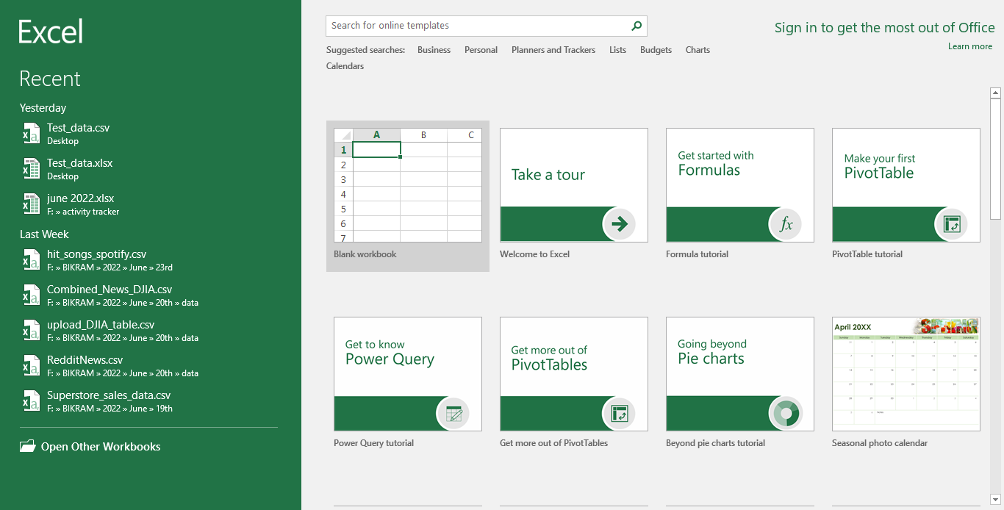

**Figure 1: Excel Interface**

1. A cell or a range of cells' number or name is referred to as a cell reference. It consists of the column name and row number together. It aids the computer programme in locating the cell from which the data or number is to be taken for the computation. In Excel, the standard cell reference is a relative reference. Without the dollar ($) sign, it is generally a combination of the column name and row number (Debortolli *et al.* 2019). The relative cell address changes depending on the relative position of the column and row when a user copies a formula from one cell to another.

# References

Debortolli, C., Dalbosco, L., Oppelt, D., Ruiz, W.A., Pedroso, R.B. and Jensen, L.A., 2019. TUTORIAL EXCEL PARA PARAMETRIZAÇÃO DE CURVAS ANALÍTICAS. *VETOR-Revista de Ciências Exatas e Engenharias*, *29*(1-2), pp.52-68.

Kaula, R. and Kaula, R., 2018. Analyze data with excel power pivot: A tutorial. *International Journal of Information, Business and Management*, *10*(4), pp.102-116.